

PROJECT: PP4E Website
GROUP NO: 02 - BATCH: T1.2010.E0

A. SYSTEM REQUIREMENTS:
Sr. | Item | Description
1. | Operating system | Windows 7, 8, or higher
2. | Hardware | CPU Cores or better with 2 Gigabytes of RAM or better
3. | Web Browser | Version in later of: Edge, Firefox, Chrome, etc…
4. | Fonts | Standard font Unicode: Arial, Tahoma, Lucida Console, Times New Roman, etc…
5. | Other requirement | NodeJS, Git, XAMPP 7.3 or later | A working internet connection.
Notes: Do not install IDEs (Integrated Development Environment) on the system such as MS Visual Code, Dreamweaver, Netbeans, etc.

B. Program Instrallation
For Adminpage
Step 1. Copy Source code or clone Project from GitHUB intto your PHP root folder (for example Drive C:\xampp\htodcs)
Step 2. Install Database in PHPMyAdmin.
Step 3. Open folder …\Group02-eProjectSem02\admin - laravel\adminPage and run GitBash or CMD
Step 4. Run Command: ‘composer install’
Step 5. Run Command: ‘composer update’ (If your computer suggest)
Step 6. Run Command: ‘npm install’
Step 7. Run Command: ‘cp .env.example .env’ (If you use GitBash)
Or ‘copy .env.example .env’ (If you use CMD)
Step 8. Set file .env in folder …\Group02-eProjectSem02\admin - laravel\adminPage with DB_DATABASE=pp4e
Step 9. Run Command ‘php artisan key:generate’
Step 10. Run Command ‘php artisan migrate’
Step 11. Run Command ‘php artisan serve’
Step 12. Open URL. ‘http://localhost:8000/’ (please use Google Chrome for website in the best experience.)

For Homepage(FE Website)
Step 1. Open folder …\Group02-eProjectSem02\FE website – react and run new GitBash or CMD
Step 2. Run Command ‘npm install’
Step 3. Run Command ‘npm start’
Step 4. Open URL. ‘http://localhost:3000/’ (please use Google Chrome for website in the best experience.)

C. Successful test
- The website is loaded successfully.
- AdminPage should be displayed as described in the documentation.
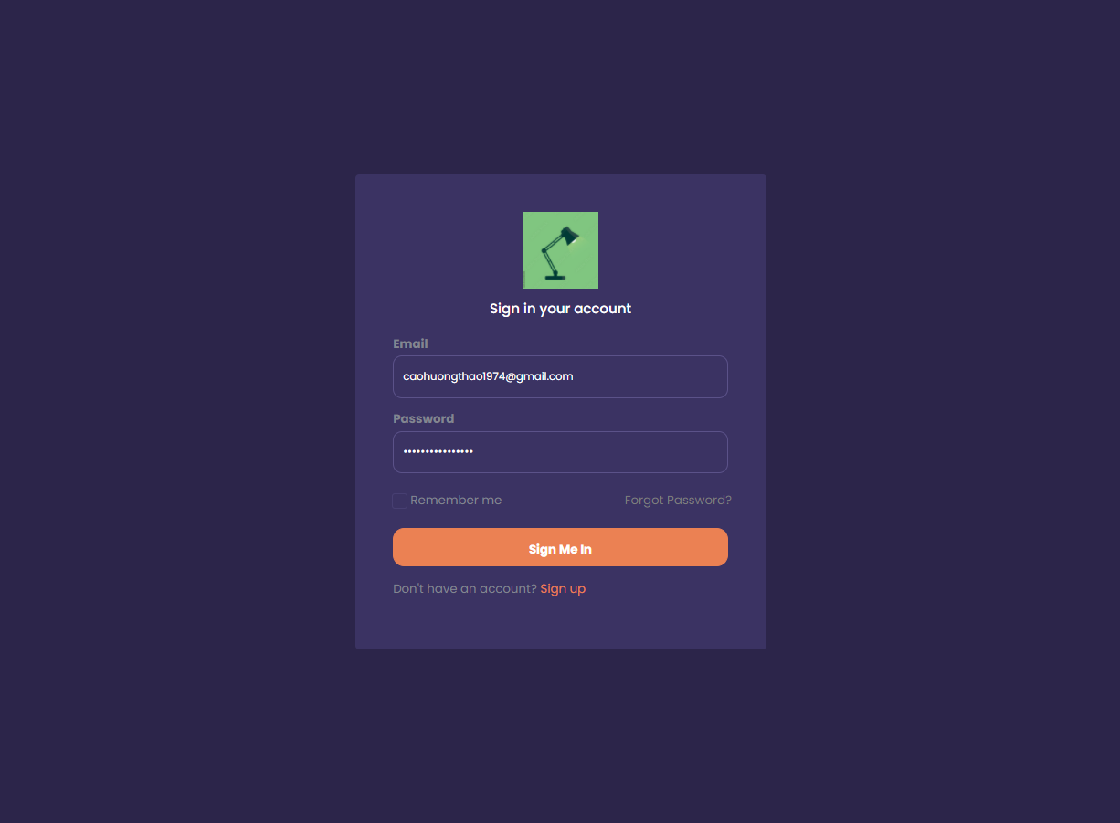

- HomePage should be displayed as described in the documentation.


